Global Climate Change

By Frederick N. Chase

# Introduction

Climate, global or not, and perhaps changing is understood by everyone. It’s hot there. It’s dry there. There’s a lot of pollen there every spring. But can scientists discuss it, make predictions about how it will change over centuries, what will be causing those changes, what mankind’s options are for influencing such changes?

It is natural to take a term in common usage, Climate, and as it becomes more used, more important, to try to capture the meaning and sharpen it up and use it for scientific purposes. But real scientists are always tinkering with this approach and actually doing the opposite. Think about the definition of force, heat, magnetism, atom, light. Scientists want to use terms and concepts they can measure and reason and relate with precision to terms already in use. In the case of Climate, terms like heat, temperature, energy, sea level, and others. So this paper takes the bull by the horns, and goes back to first principles.

What is Climate. To begin with, what is it that that may change, and how can we know how much it has changed.

And we are not so much asking what the lexicographer would ask but what would scientists find usable. We will invent a new word for that concept, if we must. Because we must.

## What is Climate

In this section we

1. consider the commonsense idea that Global Climate is the worldwide average surface temperature of Earth in degrees Centigrade.
2. We then reject the notion as unusable in favor of total heat content of earth’s mantle.
3. Finally, we reject **both** these scalar notions and acknowledge that climate as understood and used by scientists is or will, sadly, be a **rating**.

This is not what what the scientists want: this what the customer, the governemnts of the world, ***demand***.

The best we can hope for is that the Total Heat Content definition of Climate will survive as what is called Climate Hotness Index, currently section 3.1.1 of this document.

### Is Climate a Scalar or a Rating?

In this section we acknowledge that climate as understood by scientists can only be a rating and give as an example the North American Climate Rating. This climate rating is already in use, is standardized in elaborate detail, but is only vanishingly visible in all the treaties, media discussions, scientific papers, and public discourse.

#### Climate as a Scalar

In this section we consider the commonsense idea that Global Climate is the worldwide average surface temperature of Earth in degrees Centigrade. We then reject this notion in favor of another, more demanding but much more workable definition: total heat content of earth’s mantle.

If Climate can be measured as a scalar quantity then the scientific approach of measuring its change is simply the change in the scalar magnitude with respect to the change in time over that same time interval. Simple intuitive reasoning is available to discuss *changes* in Climate. For example, one can reason with certainty that if Climate increases one year and decreases by the same amount the following year that Climate did not change over that 2 year period.

Most people in the world view, or imagine most of the time that they view Climate as a scalar of one or the other of the two following scalars.

##### Surface Temperature Definition of Climate

A temperature Definition of Climate would presumably involve some measure of central tendency (mean, median, mode, …) of a large number of individual weather station measurements.

The numerous challenges involved in a Surface Temperature Definition of Climate approach are widely known and accepted solutions exist, though any / all of them can be challenged. In the 20th century and since, there has been much more attention paid to the equivalent to a worldwide network of weather station via the use of satellites and computers. Therefore, going forward, humans can hope for increasingly better data for climate modeling as we build up toward a century or more of carefully preserved, untampered, well-documented, widely available, and extremely precise global surface temperature data sets.

##### Total Heat Content Definition of Climate

Our proposed definition of Climate based on total heat (energy) content is the following.

***Climate: the total accumulated heat in the whole Earth System that resulted from the imbalance between incoming solar energy and outgoing heat and reflected energy, since 1960.[1]***

An example of this approach was in use in 2012 by Nuccitelli et al. when the following climate change information was offered.

Climate Change from 1960 to 2012

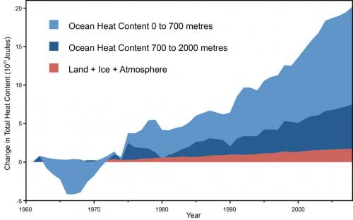

Global warming is the total excess heat in the whole Earth System that has resulted from the excess of incoming solar energy over outgoing heat and reflected energy. The figure above from [Nuccitelli et al. (2012)](http://skepticalscience.com/nuccitelli-et-al-2012.html) [[PDF](http://www.skepticalscience.com/docs/Comment_on_DK12.pdf)] shows the change in the total heat content of the Earth System since a start time of 1960 and a somewhat arbitrary zero point of energy of 1022 joules, in terms of its major components:

* the total land, atmosphere, and ice heating (red) from [Church et al. (2011)](http://www.skepticalscience.com/The-Earth-continues-to-build-up-heat.html), and
* the ocean heating for the 0-700 meter layer (light blue) and
* the 700-2,000 meter layer (dark blue) from [Levitus et al. (2012)](http://www.skepticalscience.com/levitus-2012-global-warming-heating-oceans.html).

More than [90% of global warming goes into heating the oceans](http://www.skepticalscience.com/graphics.php?g=12), while less than 3% goes into heating the atmosphere. Even relatively small exchanges of ocean heat with the atmosphere, as occurs during the El Niño Southern Oscillation (ENSO), can produce [short-term fluctuations](http://www.skepticalscience.com/graphics.php?g=14) and pauses in the increasing air temperature.

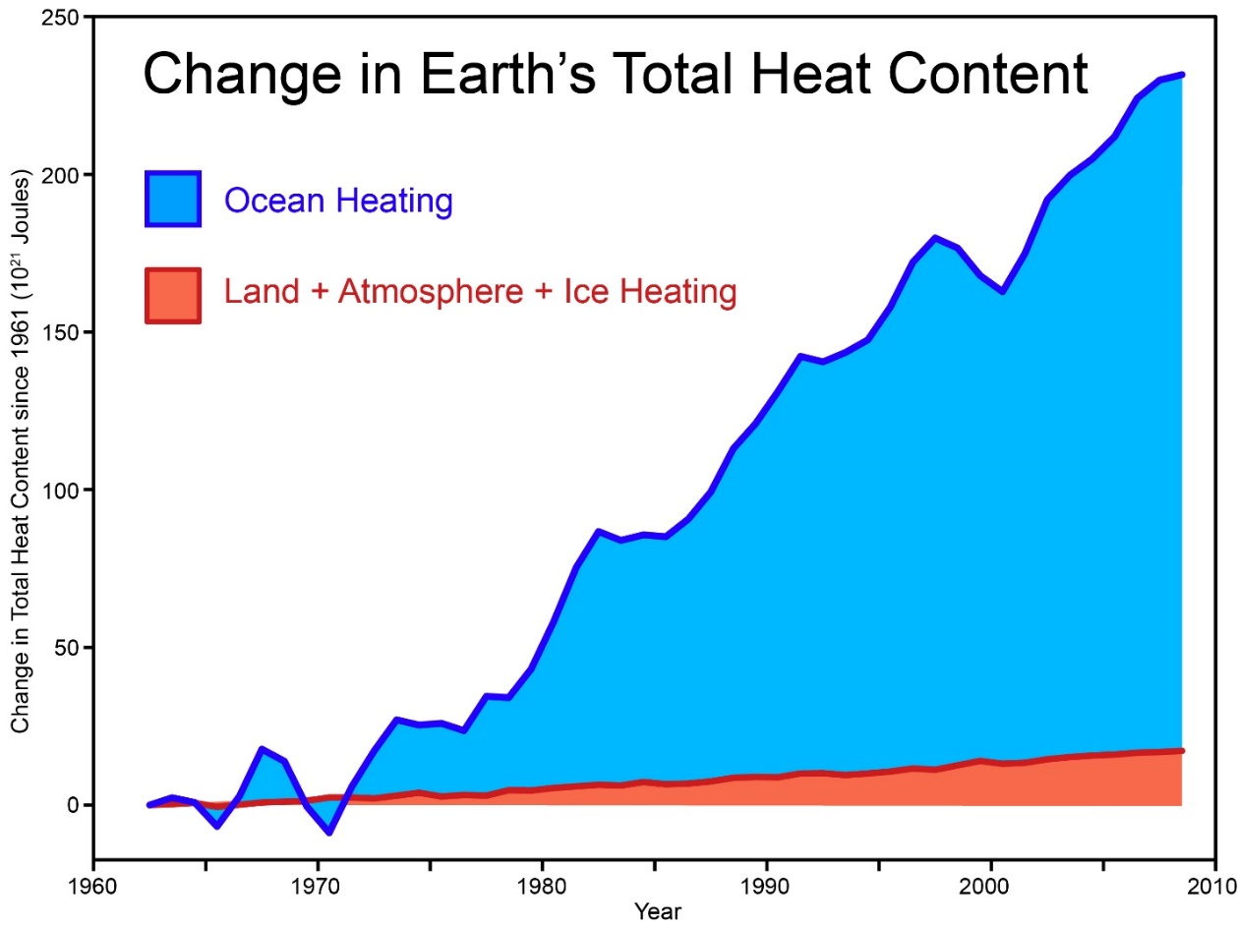

Total amount of heat from global warming that has accumulated in Earth's climate system from 1962 to 2008, from [Church et al. (2011)](http://onlinelibrary.wiley.com/doi/10.1029/2011GL048794/abstract) (many thanks to Neil White from the CSIRO for sharing [their data](http://www.skepticalscience.com/pics/Church_2011_Total_Heat_Content.xlsx)).  Also [see this graphic](http://www.skepticalscience.com/graphics.php?g=65) that shows the ocean heating in two layers, 0-700 meters and 700-2000 meters deep.  
  
Carbon dioxide from burning fossil fuels, and other greenhouse gases, absorb and trap heat energy that would otherwise be radiated to space, and since the input of energy from the sun is about constant on average, there is an energy imbalance and heat accumulates in Earth's climate system.  About 90% of the excess heat of global warming goes into heating the oceans, and only about 3% of global warming goes into heating the atmosphere ([see summary here](https://skepticalscience.com/graphics.php?g=12)).  The ocean has such a high heat capacity relative to the land and atmosphere that relatively small exchanges of heat between the ocean and atmosphere can cause significant changes in the surface temperature.

This internal shuffling around of heat within our climate system is why the surface temperature record is such a noisy signal. To see how noisy, view the following diagram.

Total Heat Content vs Surface temperature 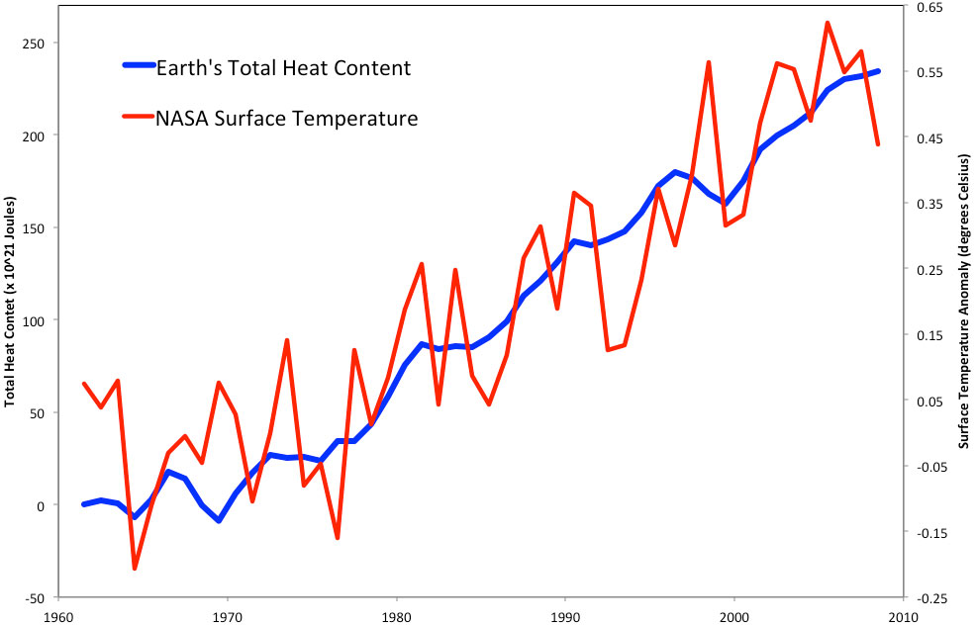

Using a total heat content definition of climate, our discourse on Climate Change would contain statements such as:

“In 2000 the earth's climate was 2 times 10 to the 23rd Joules but now in 2014 it is 4.1 times 10 to the 23rd Joules. We estimate that without anthropogenic warming, it would be 4.008 times 10 to the 23rd Joules.”

###### Climate Change Heat Flow Magnitudes

We can use a base of 100 (x 10^20 joules per year) (call it "Base"), as a long-time average amount of global warming. This somewhat arbitrary Base, is a unit as good as any for discussing global warming components, such as ocean heating.[2]

For perspective

* All the energy released (including waste or exhaust heat) from burning fossil fuels is 25% of Base.
* The amount of heat that heats the land/surface atmosphere is about 2% of Base.
* Melting ice (both ice sheets and Arctic) is about 3% of Base.

##### Best Scalar: Conclusion

It is clear from the **Total Heat Content vs Surface temperature** chart above that the total heat content the best, actually the only, usable scalar usable as a meaningful basis of the term Climate and thus the surface temperature definition must be scrapped as a hopelessly simplistic scientific definition of Climate. In fact, all cutting edge research already acts on this fact. The Media and the Public trail behind -- frozen in what they ‘learned’ in the past.

#### Climate as a Rating

By the time one scans the first appendix below, one is forced to acknowledge that Climate (for the purpose of discussing scientific predictions of Climate Change into future decades and centuries, must be a rating. Since Climate must be measured as a *rating* it could be structured (defined) substantially like a Consumer Reports rating of an automobile or camera or like air quality. A *Climate* rating would assist individuals, corporations, and countries to assess the suitability of the world or a region of the world for an intended use.

A rating must have

* a ***scope*** (what’s measured and included versus what’s not.). For Climate Presumably both a certain geographic scope and a certain time interval.
* an enumeration of ***beneficiaries*** (turtles, plankton, coral reefs, humans, polar bears, corporations, farmers, citizens, ….)
* a ***defining body*** such as the U. S. Department of Commerce or the International Standards Organization.

An example “North American Climate Rating” is given as the first appendix, below.

See Wikipedia discussion of scope.

## What is Change

Let’s assume that we are talking about change *with respect to* ***time***.

### Time Interval (Minimum Duration of Change)

In general let’s agree / define that

* **“climate”** change is fundamentally over periods not less than hundreds of years while
* decade – to - decade changes are **“weather”** changes.

We could, though, be talking about the [region](https://en.wikipedia.org/wiki/Instrumental_temperature_record#Global_record_from_1850) aspect of the changes scope.

# Proposed Definition of Climate Change

Once we agree on a scalar definition of climate, we will find that we don’t need a definition of climate *change*. Climate Change is simply the time rate-of-change of Climate.

There are several time periods recognized in the media and by individual people. Datasets have been collected and are curated covering these and other periods.

* **AGW susceptible climate change**: [1850 to present.](https://en.wikipedia.org/wiki/Instrumental_temperature_record#Global_record_from_1850)
* **Interglacial climate change**: 500,000 years or more. “The fourth previous interglacial which started about 418,000 years ago was by far the longest at about 25,000 years.”

# Appendixes

## The North American Climate Rating

The North American Climate Rating was proposed in early 2015 by Fred Chase as a replacement for the term Climate, as in “Climate Change”. Some of its components are specific to North America, and some are global.

We notice immediately that Climate Index, as defined above, is changed to Climate Hotness Index in order to carry its meaning forward but also to allow 9 or so peer indices such as a Wildfire Index within the new North American Climate Rating.

### Climate Hotness Index

This is not Global Average Earth Surface Temperature (Degrees Centigrade) but Earth Mantle Heat Content (joules). TBD

### Extreme Weather Index

as measured by the [U.S. Climate Extremes Index](http://www.ncdc.noaa.gov/extremes/cei/) (CEI)

### Biodiversity Index

With emphasis on extinction of extinction of Charismatic Species such as [Monarch Butterflies](http://www.washingtonpost.com/news/energy-environment/wp/2015/02/09/the-monarch-massacre-nearly-a-billion-butterflies-have-vanished/), and [Charismatic megafauna](http://en.wikipedia.org/wiki/Charismatic_megafauna)

### [Drought index](http://www.ncdc.noaa.gov/societal-impacts/cmsi.php)

*The Palmer Z Index*

### [Residential Energy Demand Temperature Index (REDTI)](http://www.ncdc.noaa.gov/societal-impacts/redti/)

*Based on population weighted heating and cooling degree days.*

### [Air Stagnation Index](http://www.ncdc.noaa.gov/societal-impacts/air-stagnation/)

*Maps of percent of month (summer months only) with above threshold stagnation.*

### [U.S. Wildfires](http://www.ncdc.noaa.gov/societal-impacts/wildfires/)

*U.S. Wildfire data and statistics.*

### [Heat Stress Index](http://www.ncdc.noaa.gov/societal-impacts/heat-stress.php)

*The combined effects of temperature and humidity cannot be directly measured but can be assessed by calculation of an "apparent temperature".*

### [Northeast Index to Potential Ozone Exposure (provided by the NERCC)](http://www.nrcc.cornell.edu/ozone/)

### Sea Level Index

Ocean Level threat to Humans , meaning monetary damage, as a % of GDP, to every metropolitan area with over 5 million people, of a rise of over 50 meters per 1000 years.

## Datums

A measure of, say, global climate, at a moment in time is, minimally, a number (average surface temperature perhaps)..To get the value of this global value requires a number of samples from around the world at that time, a trusted repository for those values, a collection network, and a sharing network. As well as understanding of the supposed meaning of the data, trust in the custodianship of the data is necessary. To study the *change* in, say, Climate or Sea Level, one must store repeated time slices for every epoch time of interest. Two specific groups of Datums are discussed below: surface temperature and sea level.

### Surface temperature and its Change

There are five official surface temperature datums (data records).

Three of these are based on measurements taken on the Earth’s surface, versions of which are then compiled by Giss, by the US National Oceanic and Atmospheric Administration (NOAA) and by the University of East Anglia’s Climatic Research Unit working with the Hadley Centre for Climate Prediction, part of the UK Met Office. The three surface records, all run by passionate believers in man-made warming, in fact derive most of their land surface data from one source. This is the Global Historical Climate Network (GHCN), managed by the US National Climate Data Center under NOAA, which in turn comes under the US Department of Commerce. This is matched by the CRUTEM and HadCRUT (land surface) and HadSST (ocean surface) data. Ref Longhurst p 79.

The other two records are derived from measurements made by satellites, and then compiled by Remote Sensing Systems (RSS) in California and the University of Alabama, Huntsville (UAH).

Other temperature datums

#### Temperatures at a given Latitude and Longitude over Large Time Intervals.

In 2001, Russian geologist Sergey Kotov used the mathematics of chaos to analyse the atmospheric temperature record of the past 4000 years from a Greenland ice core.[3]

#### Other, non “big five” datums

There are, for example the 1881-2002 temperature records for China.

### Sea Level and its Change

See the second appendix of this document for much more depth.

## Sea Level Change Discussion

### Geodetic Systems

A **Geodetic system** or [**geodetic datum**](http://en.wikipedia.org/wiki/Geodetic_datum) is a [coordinate system](http://en.wikipedia.org/wiki/Coordinate_system), and a set of reference points, used to locate places on the [Earth](http://en.wikipedia.org/wiki/Earth) (or similar objects).

The modern (from 1984 onward) definition of [sea level](http://en.wikipedia.org/wiki/Sea_level) is defined precisely by the datum [WGS 84](http://en.wikipedia.org/wiki/World_Geodetic_System).

### Datums

A [*geodetic datum*](http://en.wikipedia.org/wiki/Geodetic_datum)supports one or more of

* [geodesy](http://en.wikipedia.org/wiki/Geodesy),
* [navigation](http://en.wikipedia.org/wiki/Navigation),
* [surveying](http://en.wikipedia.org/wiki/Surveying) by [cartographers](http://en.wikipedia.org/wiki/Cartographer)
* [satellite navigation systems](http://en.wikipedia.org/wiki/Satellite_navigation_system)

to translate positions indicated on [maps](http://en.wikipedia.org/wiki/Maps) (digital as well as paper) to their real position on [Earth](http://en.wikipedia.org/wiki/Earth).

#### WGS 84

The **World Geodetic System** ([**WGS**](http://en.wikipedia.org/wiki/World_Geodetic_System)) is a standard suitable minimally for [cartography](http://en.wikipedia.org/wiki/Cartography), [geodesy](http://en.wikipedia.org/wiki/Geodesy), and [navigation](http://en.wikipedia.org/wiki/Navigation). It comprises

1. a standard [coordinate system](http://en.wikipedia.org/wiki/Coordinate_system) for the [Earth](http://en.wikipedia.org/wiki/Earth). ( The coordinate origin of WGS 84 is meant to be located at the Earth's [center of mass](http://en.wikipedia.org/wiki/Center_of_mass); the error is believed to be less than 2 cm. )
2. a standard [spheroidal](http://en.wikipedia.org/wiki/Spheroid) [*reference ellipsoid*](http://en.wikipedia.org/wiki/Reference_ellipsoid) for raw [altitude](http://en.wikipedia.org/wiki/Altitude) data, and
3. a [gravitational](http://en.wikipedia.org/wiki/Gravitation) [equipotential surface](http://en.wikipedia.org/wiki/Equipotential_surface) (the [*geoid*](http://en.wikipedia.org/wiki/Geoid)) that defines the *nominal sea level*.

The terms sea level and **mean sea level (MSL)** are used interchangeably in casual conversation even though they are only equal twice a day. Neither include variations owing to weather events. Sea level (at a given moment) is not of interest in Climate science as opposed to Weather science.

The modern definition of [sea level](http://en.wikipedia.org/wiki/Sea_level) involves the use of [WGS 84](http://en.wikipedia.org/wiki/World_Geodetic_System). WGS 84 is currently the reference system being used by the [Global Positioning System](http://en.wikipedia.org/wiki/Global_Positioning_System). It is geocentric and globally consistent within ±1 m.

#### Other Geodetic Datums

 Other datums have been defined at other times.

The traditional reference ellipsoids or [*geodetic datums*](http://en.wikipedia.org/wiki/Geodetic_datum) were defined regionally and therefore non-geocentric, e.g., [ED50](http://en.wikipedia.org/wiki/ED50). Modern geodetic datums are established with the aid of [GPS](http://en.wikipedia.org/wiki/GPS) and will therefore be geocentric, e.g., WGS 84.

Each starts with an [ellipsoid](http://en.wikipedia.org/wiki/Ellipsoid) (stretched sphere), and then defines [latitude](http://en.wikipedia.org/wiki/Latitude), [longitude](http://en.wikipedia.org/wiki/Longitude) and [altitude](http://en.wikipedia.org/wiki/Altitude) coordinates. One or more locations on the earth's surface is chosen as an anchor (reference point).

The difference in co-ordinates between datums is commonly referred to as [datum shift](http://en.wikipedia.org/wiki/Ordnance_Survey_National_Grid#Datum_shift_between_OSGB_36_and_WGS_84). The datum shift between two particular datums can vary from one place to another within one country or region, and can be anything from zero to hundreds of meters (or several kilometers for some remote islands). The [North Pole](http://en.wikipedia.org/wiki/North_Pole), [South Pole](http://en.wikipedia.org/wiki/South_Pole) and [Equator](http://en.wikipedia.org/wiki/Equator) may be assumed to be in different positions on different datums, so [True North](http://en.wikipedia.org/wiki/True_North) may be very slightly different. Different datums use different estimates for the precise shape and size of the Earth (different [reference ellipsoids](http://en.wikipedia.org/wiki/Reference_ellipsoid)).

Because the Earth is an imperfect ellipsoid, localised datums can give a more accurate representation of the area of coverage than WGS 84. [OSGB36](http://en.wikipedia.org/wiki/Ordnance_Survey_National_Grid), for example, is a better approximation to the [geoid](http://en.wikipedia.org/wiki/Geoid) covering the British Isles than the global WGS 84 ellipsoid However, as the benefits of a global system outweigh the locally-greater accuracy, the global WGS 84 datum is becoming increasingly adopted.

Horizontal datums are used for describing a point on the [Earth](http://en.wikipedia.org/wiki/Earth)'s surface, in [latitude](http://en.wikipedia.org/wiki/Latitude) and [longitude](http://en.wikipedia.org/wiki/Longitude) or another coordinate system. Vertical datums measure elevations or depths.

##### Ordnance Datum Newellyn

In the UK, the [Ordnance Datum](http://en.wikipedia.org/wiki/Ordnance_Datum) (the 0 metres height on UK maps) is the mean sea level measured at [Newlyn](http://en.wikipedia.org/wiki/Newlyn) in [Cornwall](http://en.wikipedia.org/wiki/Cornwall) between 1915 and 1921. Prior to 1921, the datum was MSL at the [Victoria Dock, Liverpool](http://en.wikipedia.org/wiki/Victoria_Dock_(Liverpool)).

##### OGSB36

See detailed discussion [here](http://en.wikipedia.org/wiki/Ordnance_Survey_National_Grid#General).

##### Belfast Ordnance Datum

The **Belfast Ordnance Datum** is the MSL at Clarendon Dock, Belfast, between 1951 and 1956.

##### Malin Ordnance Datum

The **Malin Ordnance Datum** was the MSL at Portmoor Pier, [Malin Head](http://en.wikipedia.org/wiki/Malin_Head), [County Donegal](http://en.wikipedia.org/wiki/County_Donegal), between 1960 and 1969.

##### Poolbeg Ordnance Datum

The **Poolbeg Ordnance Datum** was the low water of [spring tide](http://en.wikipedia.org/wiki/Spring_tide) at [Poolbeg Lighthouse](http://en.wikipedia.org/wiki/Poolbeg_Lighthouse), [Dublin](http://en.wikipedia.org/wiki/Dublin), on 8 April 1837. The Poolbeg OD was about 2.7 metres lower than the Malin OD.

##### The Marégraphe

In France, the Marégraphe in Marseilles measures continuously the sea level since 1883 and offers the longest time interval of “collapsed data” about the sea level.at a single latitude/longitude. It is used for a part of continental Europe and main part of Africa as official sea level.

##### The European Vertical Reference System

Elsewhere in Europe vertical elevation references (European Vertical Reference System) are made to the [Amsterdam Pile](http://en.wikipedia.org/wiki/Amsterdam_Ordnance_Datum) elevation, which dates back to the 1690s.

##### The ED50

In 1950, [ED50](http://en.wikipedia.org/wiki/ED50) was defined over Europe. It differs from WGS 84 by hundreds of meters depending on where in Europe you look.

### Height, Specifically

**Land Benchmarks** are used to measure MSL. For coastal sea level purposes, [Tide Gauges](http://www.oco.noaa.gov/tideGauges.html) are used now that GPS is available. However, for old historical data, various sticks and other marks were used and any data of this sort must be converted to match a datum being used.

Satellite altimeters have been making precise measurements of sea level since the launch of [TOPEX/Poseidon](http://en.wikipedia.org/wiki/TOPEX/Poseidon) in 1992. A joint mission of [NASA](http://en.wikipedia.org/wiki/NASA) and [CNES](http://en.wikipedia.org/wiki/CNES), TOPEX/Poseidon was followed by [Jason-1](http://en.wikipedia.org/wiki/Jason-1) in 2001 and the [Ocean Surface Topography Mission](http://en.wikipedia.org/wiki/Ocean_Surface_Topography_Mission) on the Jason-2 satellite in 2008.

In addition the term Continuous GPS or Continuous-tracking GPS or CGPS is being used to refer to any lashup of gps units to recording apparatus for the purpose of detecting height changes over time. This data may be used to study tectonic plate shifts, volcano activity, soil subsidence, sea level changes, Greenland ground elevation, and the like. [IMAGES](https://www.google.com/search?q=gps+geodesy&newwindow=1&biw=1710&bih=964&tbm=isch&tbo=u&source=univ&sa=X&ei=NcbLVNLEKIHCgwSvnoDwAQ&sqi=2&ved=0CDEQsAQ&dpr=0.9).

An alternative is to base height measurements on an [ellipsoid](http://en.wikipedia.org/wiki/Reference_ellipsoid) of the entire earth, which is what systems such as [GPS](http://en.wikipedia.org/wiki/GPS) do.

In aviation, the ellipsoid known as [World Geodetic System](http://en.wikipedia.org/wiki/World_Geodetic_System) 84 is increasingly used to define heights, however, differences up to 100 metres (328 feet) exist between this ellipsoid height and mean tidal height.

Mean Tidal Height is

(The **geoid** is the shape that the surface of the oceans would take under the influence of Earth's [gravitation](http://en.wikipedia.org/wiki/Gravitation) and rotation alone, in the absence of other influences such as winds and tides. This surface is extended through the continents (such as with very narrow hypothetical canals).

[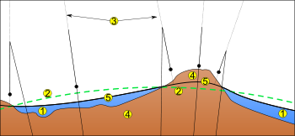](http://en.wikipedia.org/wiki/File:Geoida.svg)

1. Ocean  
2. [Reference ellipsoid](http://en.wikipedia.org/wiki/Reference_ellipsoid)  
3. Local [plumb line](http://en.wikipedia.org/wiki/Plumb-bob)  
4. Continent  
5. Geoid

All points on the geoid have the same [gravitational potential](http://en.wikipedia.org/wiki/Gravitational_potential). The force of gravity acts everywhere perpendicular to the geoid, meaning that [plumb lines](http://en.wikipedia.org/wiki/Plumb_bob) point perpendicular and [water levels](http://en.wikipedia.org/wiki/Spirit_level) parallel to the geoid. )

The alternative is to use a [geoid](http://en.wikipedia.org/wiki/Geoid) based vertical [datum](http://en.wikipedia.org/wiki/Datum_(geodesy)) such as [NAVD88](http://en.wikipedia.org/wiki/North_American_Vertical_Datum_of_1988).

Local mean sea level (LMSL) is defined as the height of the sea with respect to a land benchmark, averaged over a period of time (such as a month or a year) long enough that fluctuations caused by [waves](http://en.wikipedia.org/wiki/Ocean_surface_wave) and [tides](http://en.wikipedia.org/wiki/Tide) are smoothed out. One must adjust perceived changes in LMSL to account for vertical movements of the land, which can be of the same order (mm/yr) as [sea level changes](http://en.wikipedia.org/wiki/Sea_level_change). Some land movements occur because of [isostatic](http://en.wikipedia.org/wiki/Isostasy) adjustment of the [mantle](http://en.wikipedia.org/wiki/Mantle_(geology)) to the melting of [ice sheets](http://en.wikipedia.org/wiki/Ice_sheet) at the end of the [last ice age](http://en.wikipedia.org/wiki/Last_glacial_period). The weight of the ice sheet depresses the underlying land, and when the ice melts away the [land slowly rebounds](http://en.wikipedia.org/wiki/Post-glacial_rebound). Changes in ground-based ice volume also affect local and regional sea levels by the readjustment of the [geoid](http://en.wikipedia.org/wiki/Geoid) and [true polar wander](http://en.wikipedia.org/wiki/True_polar_wander). [Atmospheric pressure](http://en.wikipedia.org/wiki/Atmospheric_pressure), [ocean currents](http://en.wikipedia.org/wiki/Ocean_current) and local ocean [temperature](http://en.wikipedia.org/wiki/Temperature) changes can affect LMSL as well.

#### Sea Level

Sea level today is very near the lowest level ever attained (the lowest level occurred at the [Permian](http://en.wikipedia.org/wiki/Permian)-[Triassic](http://en.wikipedia.org/wiki/Triassic) boundary about 250 million years ago).

### Kinds of Changes

[There are Short term and periodic sea level changes.](http://en.wikipedia.org/wiki/Sea_level#Short_term_and_periodic_changes)

[There are Long term changes in Sea Level](http://en.wikipedia.org/wiki/Sea_level#Long_term_changes)

There are [changes through geologic time](http://en.wikipedia.org/wiki/Sea_level#Changes_through_geologic_time).

## U.S. Government Definitions Related to Global Climate Change

The Google search site:globalchange.gov define:climate change was used to locate [the following government definitions](http://www.globalchange.gov/climate-change/glossary).

**See the discussion Starting with the term Global Warming, meaning 1, (below) to understand what the U.S. Government’s definition probably is!**

**And see** [**What's in a Name? Global Warming vs. Climate Change**](http://www.nasa.gov/topics/earth/features/climate_by_any_other_name.html) **for a discussion of the terms Global Warming and Climate Change.**

Global change

Changes in the global environment[4] that may alter the capacity of the Earth to sustain life. Global change encompasses climate change, but it also includes other critical drivers of environmental change that may interact with climate change, such as land use change, the alteration of the water cycle, changes in biogeochemical cycles, and biodiversity loss. [See also climate change]

Climate change

Changes in average weather conditions that persist over multiple decades or longer. Climate change encompasses both increases and decreases in temperature, as well as shifts in precipitation, changing risk of certain types of severe weather events, and changes to other features of the climate system. [See also global change]

Climate [**Unofficial** Inferred Guess]

Average[5] weather conditions over a specified number of years or decades. When the geographic scope is unspecified Climate is Global Climate. When the time range is unspecified, Climate by default refers to the immediate past. Climate is temperature, as well as precipitation, risk of certain types of severe weather events, land use, biogeochemical cycles, and biodiversity[6].

*Global Climate [****Unofficial Inferred Guess****]*

Global Climate is Climate whose geographic scope is ‘worldwide’.

Climate variability

Natural changes in climate that fall within the observed range of extremes for a particular region, as measured by temperature, precipitation, and frequency of events. Drivers of climate variability include the El Niño Southern Oscillation and *other phenomena.*

Global warming

The observed increase in average temperature near the Earth’s surface and in the lowest layer of the atmosphere. In common usage, “global warming” often refers to the warming that has occurred as a result of increased emissions of greenhouse gases from human activities. Global warming is a type of climate change; it can also lead to other changes in climate conditions, such as changes in precipitation patterns.

Global Temperature [**Unofficial Inferred Guess**]

The observed average temperature near the Earth’s surface and in the lowest layer of the atmosphere.[7]

Global Temperature Change [**Unofficial Inferred Guess**]

The time rate of change of Global Temperature.

Global Temperature Increase [**Unofficial Inferred Guess**]

The time rate of change of Global Temperature over an interval where that number is positive.

Global Warming [**Unofficial Inferred Guess**]

Meaning 1: Synonym for Global Temperature Increase.

Meaning 2: In common usage, “global warming” often refers to the component of Global Temperature that has occurred as a result of increased emissions of greenhouse gases from human activities.

[GlobalChange.gov](http://www.globalchange.gov/home) is made possible by our participating agencies  
*Thirteen Agencies, One Vision: Empower the Nation with Global Change Science*



U.S. Government Definition of Global

1. This must a moment in Epoch Time. The example definition uses the zero point of UTC, 1960.
2. <http://dotearth.blogs.nytimes.com/2015/02/02/a-fresh-look-at-the-watery-side-of-earths-climate-shows-unabated-planetary-warming/?src=twr&_r=2>
3. Based on the pattern he recognised in the data, Kotov extrapolated cooling from 2000 to about 2030, followed by warming to the end of the century and 300 years of cooling thereafter.
4. Environment of humans?
5. throughout both a certain geographic scope and a certain time interval
6. with an emphasis on charismatic animals and those involved in animal husbandry as opposed to bacteria. (Current estimates of the number of species vary from, let's say, two million species to over 30 or even 100 million species.)
7. Note that this excludes any form of total heat content of the earth’s mantle. In particular this excludes the heat content of the oceans.